Technical Design Document

Project Name: Forex Service

Team Members:

* Shivani Padwal (46295026)
* Shalmali Nighot (46294646)

# Introduction:

* Forex Services or Foreign Exchange Services is exchanging a particular currency converting cash into another country Currency.
* Forex exists so that large amounts of currency can be exchanged for the equivalent value in another Country currency at the current market rate.

# Problem Statement:

* To create an application based on Forex Service.
* Users should save their details on the application for registering.
* Users can view current rates of world currencies and their conversions.
* Users can send between any of these currencies.
* Users can view graph which shows some historical data.
* Transferring money to another bank can include Recipient Bank Details and any other details needed.
* After transaction small transaction fee should be collected.
* After transaction, Users can download transaction Data in PDF format.

Admin can manage the currency rates for particular days.

* Admin can generate reports on how much they have earned based on days, months & years.
* Other data that be generated contain things like which currencies where mostly send, which countries, which user is the most frequent one, etc.

# Functional Requirements:

The functional requirements of the project are:

## For the Admin:

* Login/Register
* Manage Currency Rate
* Generate Report of how much they earned, the Frequent Countries where money Send, etc.
* Convert Currency

## For the User:

* Login/Register
* Transaction
* Add Bank Details
* View Transaction
* Update Bank Details

**Micro-Services:**

The different micro-services in which this project is divided into are:

* **User Service:** Register a new account and login (as a customer) and login (as the admin).
* **Bank Service:** Add, Update and View Bank Details.
* **Currency Service:** We can view and update currency rate.
* **Charges Service:** Add, update and calculate the charges on the specific amount.
* **Report Service:**  Provide a report of how much they earned, where most currency send to which people and the countries.
* **Transaction service:** Add Transaction, view transaction history.

# 

# Overall Architecture

# 

**Class Diagrams**

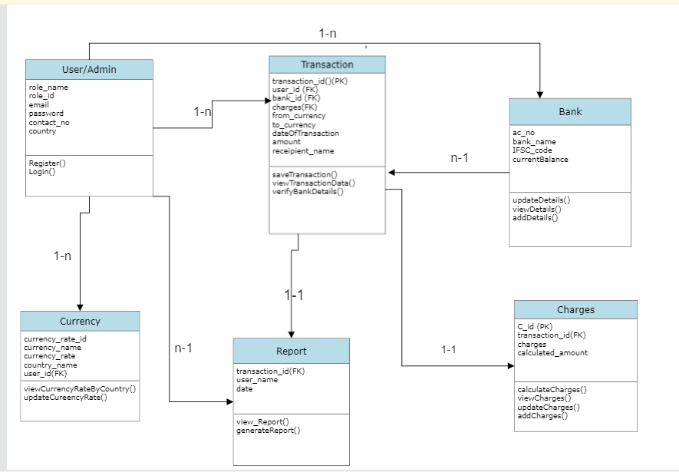

**Use case Diagram**

* User and Admin Services

**Activity Diagrams**

* 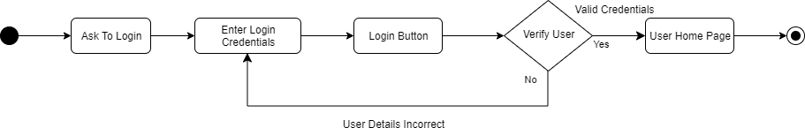Login
* 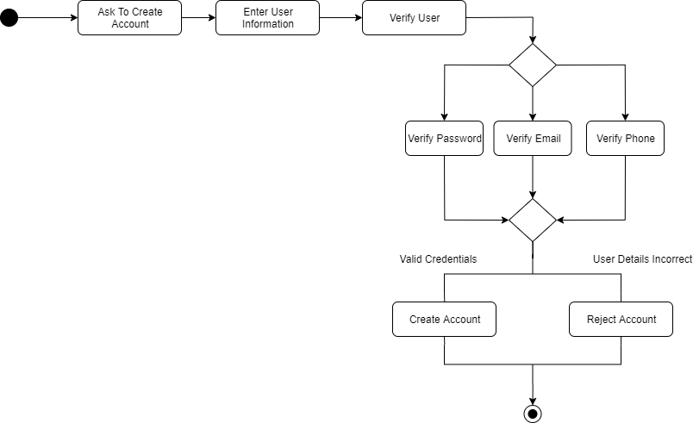Registration
* Transaction

* Currency

**Sequence Diagram**

**Database Diagram**

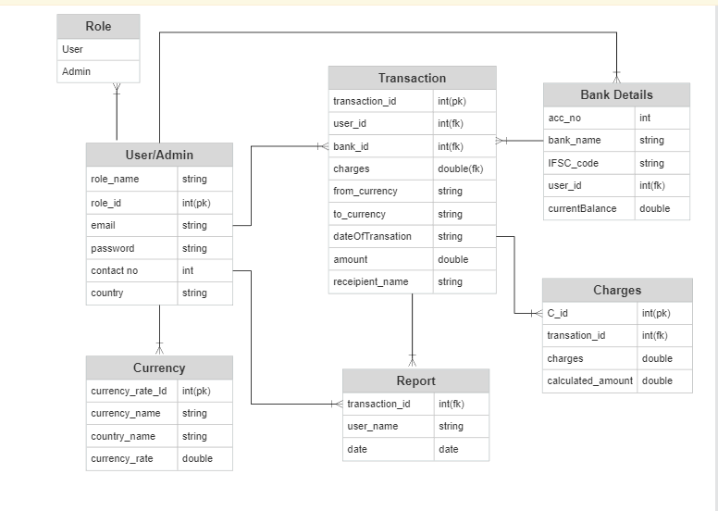

**Activity Diagrams**

**Wire Framing**

**User Services**

* Login Page

* Registration Page

**Transaction Services**

* Transferring Money

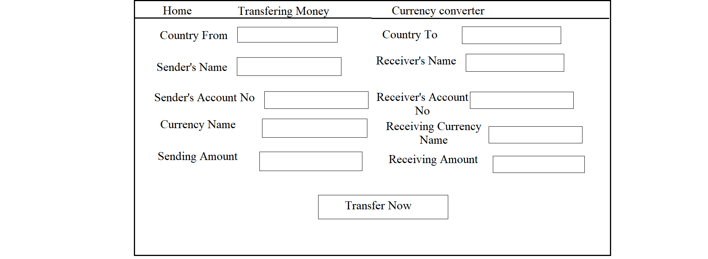

* View Transaction

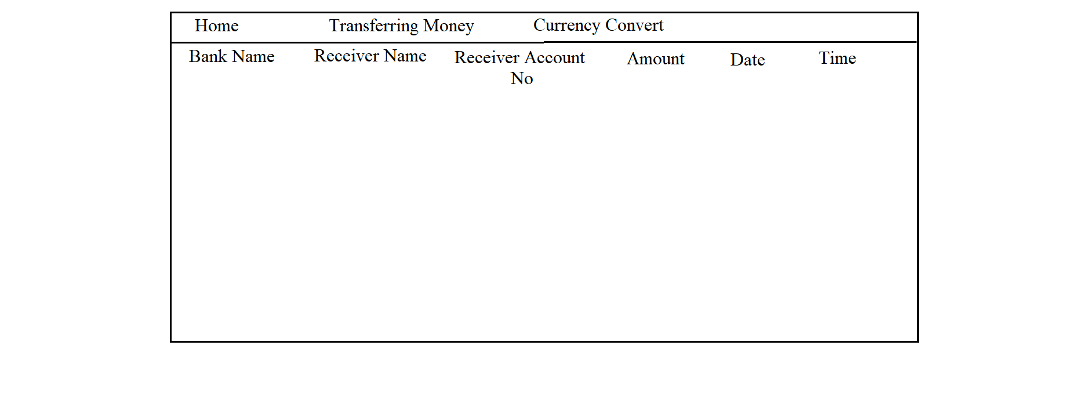

**Bank Services**

* Add Bank Details

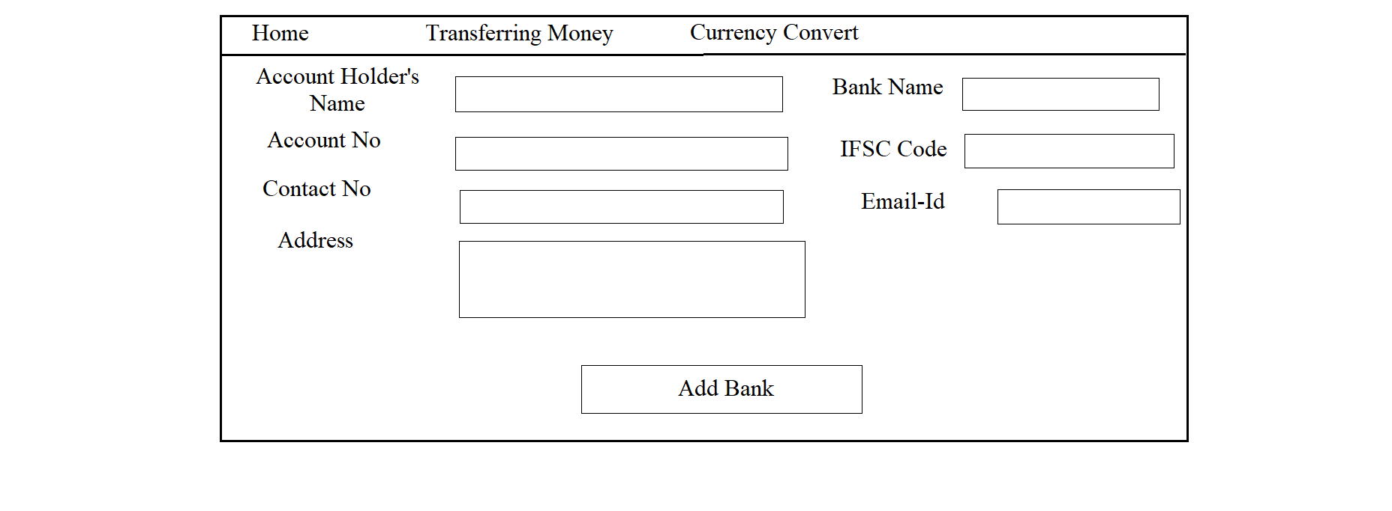

* Update Bank Details

**Currency Services**

* Currency Converter

